 |  | 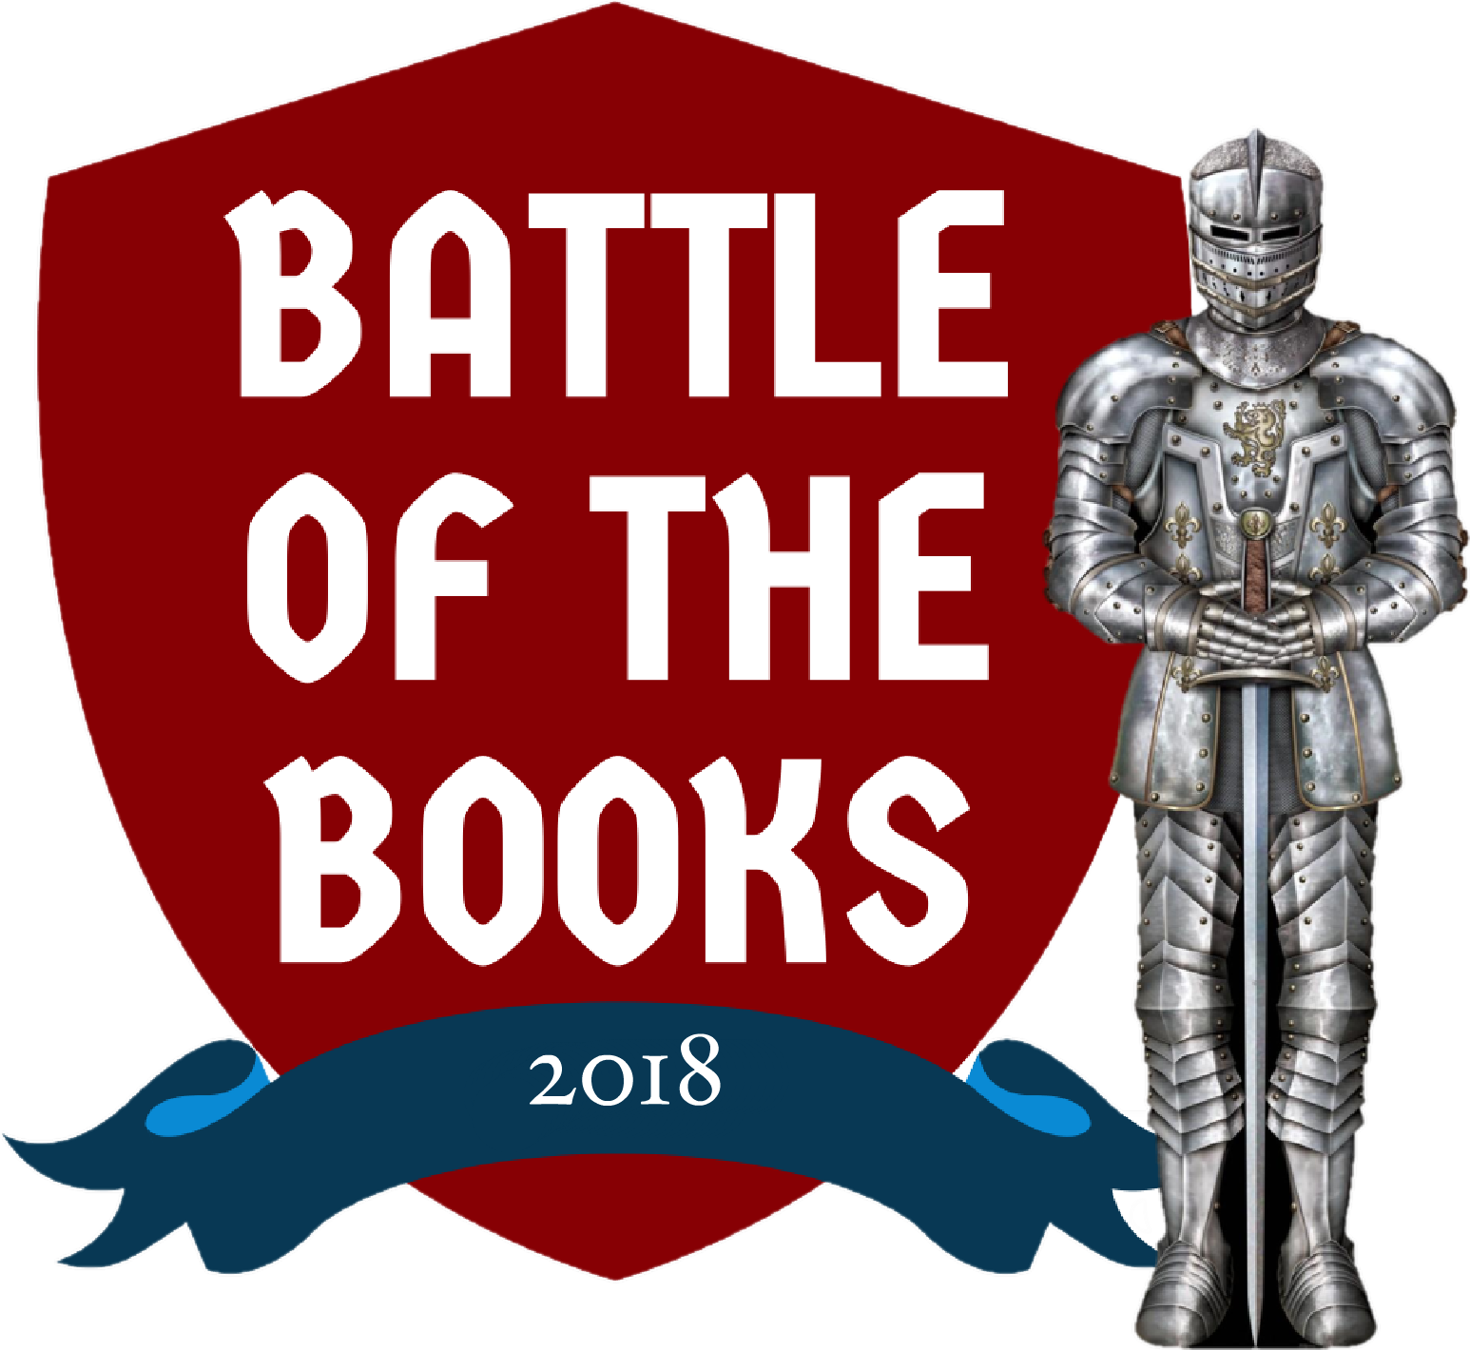  McBain Community Library  107 E. Maple St.  McBain, MI 49657  231-825-2197  Ardis-Missaukee District Library  201 S. Canal St  Lake City, MI 49651  231-839-2166  Best of Luck to All 2018 Competitors!  Brought to you by:  McBain Community Library  Ardis Missaukee District Library  Houghton Lake Public Library  Roscommon Area District Library  Otsego County Library  Richfield Township Public Library | Grades 4-6  Registration begins December 11 | 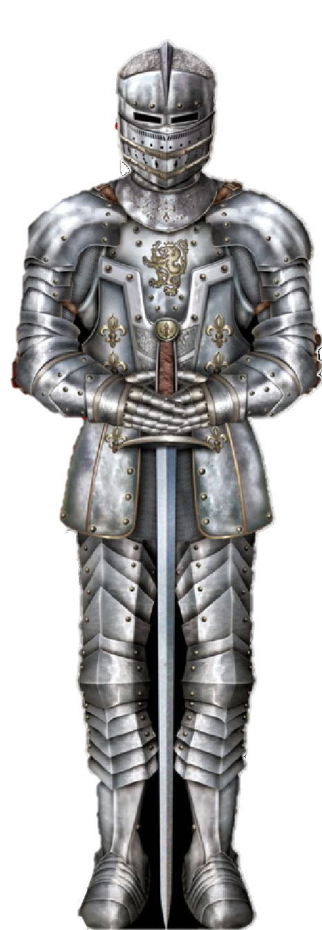  BATTLE OF THE BOOKS 2018
Registration Form
Registration closes on
January 13th at 5pm

Each member of your team must complete a separate form.
Please Fill out both sides, tear off this form, and return it to the library.

Name: _____________________________

Team Name (If known):

Grade: _____________ Age: ________

Phone Number: ____________________

Optional:
Please list the names of any friends (up to 4) or a coach who you’d like to be teamed up with. Remind your friends to turn in their registration forms too!

Coach (if known):

All activities and materials are free to participants.
Schedule for McBain/Lake City  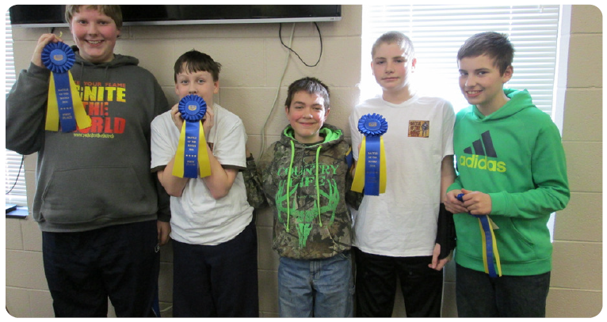  Kick Off  January 13th at 11am  Students and coaches meet at the McBain Community Library, receive books and design team t-shirts  Author Visit  February 6th at 4:00pm  Meet the author of one of our BoB Bookss" in a special presentation and dinner just for BoB participants. |  | Mock Battle  February 24th at 11 a.m.  McBain/Lake City teams meet for a practice battle at the McBain Community Library. Be ready to compete with all 10 books!  Local Elimination Battle  March 10th at 11 a.m.  McBain/Lake City teams meet at the McBain Community Library to battle for the chance to compete in the finals! The top three teams will advance to the finals against the other libraries’ teams.  Grand Championship Battle  March 17th at 1pm  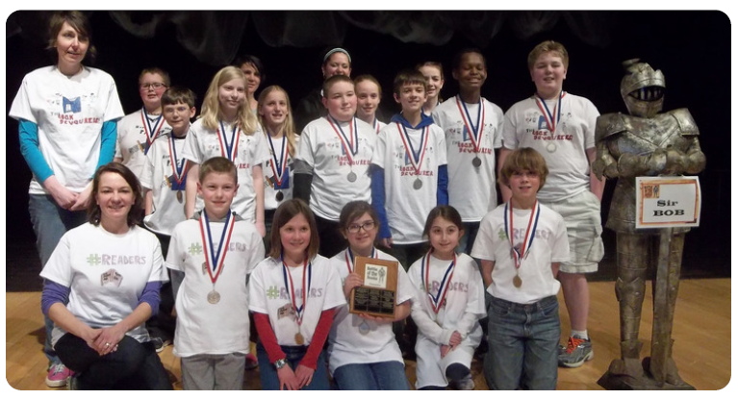  The top three teams from each library meet at Houghton Lake High School Auditorium for the 2018 Championship! All participants, their families, friends, and the general public are welcome! Participants must arrive by 12:30 pm |  | How Battle of the Books Works  Students compete in teams of five lead by an adult coach. They read a variety of books chosen by librarians, and then answer questions about the books in a competition against other local teams. The top three teams from each library go on to compete against the teams from their “rival” libraries. The team with the most correct answers becomes the 2018 Battle of the Books Champion! Complete rules are available at your library.  -P a r e n t s-  Please review the attached schedule and sign below  My Child _________________________________  has my permission to participate in the 2018 Battle of the Books.  I understand that photographs, video, or audio recordings taken in connection with Battle of the Books may be used to publicize the program and/or the Library’s public service. Without reservation, I irrevocably authorize the Library to copy, exhibit, publish or distribute any and all such images and audio of my child for such purposes. In addition, I waive any right to inspect or approve the finished product wherein my child’s voice and likeness appears, or any written copy that may accompany it, in whatever format used.  Signed: ___________________________  Printed: ___________________________

